Biomedical Data Science & AI

**Exercise sheet 9**

SoSe2022

Prof. Dr. Holger Fröhlich, Mohamed Aborageh, Vinay Bharadhwaj, Yasamin Salimi

**Due date: June 21st**

**Note:** Please include your group members’ names, matriculation numbers and emails at the beginning of your answer sheet. Send your solutions (both ipynb and pdf files) to the corresponding tutors via email:

* Mohamed Aborageh: [maborage@uni-bonn.de](mailto:maborage@uni-bonn.de)
* Vinay Srinivas Bharadhwaj: [s0vibhar@uni-bonn.de](mailto:s0vibhar@uni-bonn.de)
* Yasamin Salimi: [yasisali@uni-bonn.de](mailto:yasisali@uni-bonn.de)

**Questions**

**Exercise 1 - Ensemble Learning (8 points)**

1. Using the *titanic_survival_dataset.csv*, train the following (scikit-learn) models using nested cross validation while optimizing a selected number of hyperparameters in the inner loop using grid search, then compute the probabilities of the outcomes:
   1. Random forest, optimizing the number of estimators **(1 point)**
   2. Gradient boosting, optimizing boosting steps **(2 point)**
   3. Lasso penalized logistic regression, optimizing L1 regularization strength **(1 point)**

**Note:** Using a large parameter grid results in an extended computation time. We advise using a maximum of 5 values per hyperparameter

1. Inform yourself about calibration curves (reliability diagrams).
   1. Describe how calibration curves can explain your model’s performance.   
      (1 point)
   2. Use the predicted probabilities of each model from question 1 to plot a calibration curve, then explain your results. **(3 points)**

**Exercise 2 - NN theoretical (10 points)**

1. Suppose there is a Multi-Layer Perceptron (MLP) composed of one input layer with 8 neurons, followed by one hidden layer with 30 artificial neurons, and one output layer with 3 artificial neurons. All artificial neurons use the ReLU activation function.
   1. Deduce the shape of input matrix X, hidden layer’s weight vector Wh, bias vector bh and the shape of the network’s output matrix Y. **(2 points)**
   2. Write the equation that computes the network’s output matrix Y as a function of X, Wh , bh , Wo and bo. **(2 points)**
2. What are the principal and unavoidable limitations of the backpropagation (BP)? **(1 point)**
3. The shown figure is a 3 layer neural network.
4. Compute h1, h2, o1, and total error using ReLU units. **(2 points)**

**Note:** b1, b2 and b3 represent the biases added to their respective units.

1. Calculate the updates of the network weights w1, …, w6 and bias terms b1, b2, b3 using backpropagation. Assume a learning rate of 1 for the sake of simplicity. **(3 points)**.

**Note:** Remember that a bias term is equivalent to a weighted constant input 1.

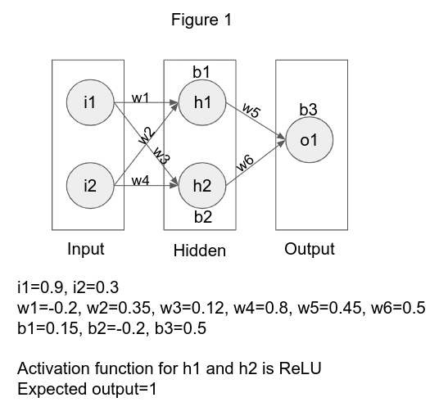

**Exercise 3 - NN Programming (7 points)**

1. Familiarize yourself with TensorFlow and train a neural network with 2 hidden layers (10 and 8 units respectively) and predict the label feature using the *titanic_survival_dataset.csv* dataset. **(2 points)**
2. Evaluate the performance of the neural network for the same dataset in a nested cross validation by optimizing the number of units in the 2nd hidden layer in the inner cross validation. **(3 points)**
3. How does the neural network perform in comparison to the models in the calibration curve from the previous task and plot the results alongside the other models in the calibration plot? **(2 points)**